<<COURT_NAME>>

|  |  |
| --- | --- |
| <<PROVIDER_SUITNAME>>,  a/a/o <<INJUREDPARTY_NAME>>    Plaintiff,  vs.  <<INSURANCECOMPANY_SUITNAME>>  Defendant. | Case No. <<INDEXORAAA_NUMBER>> |

__________________________________________/

**REQUEST FOR COPIES**

Plaintiff, <<PROVIDER_SUITNAME>>, by and through the undersigned counsel, hereby requests Defendant, <<INSURANCECOMPANY_SUITNAME>>, to provide copies to Plaintiff of all documents that were received pursuant to a Subpoena Duces Tecum submitted to the following persons/entities:

________________

________________

**If the copy cost for this Request for Copies is anticipated to exceed $10.00, please contact the undersigned prior to making the copies.**

**CERTIFICATE OF SERVICE**

I HEREBY CERTIFY that on February 19, 2022, a true and correct copy of the foregoing was sent by E-MAIL to <<OPPOSING_COUNSEL_NAME>>, <<OPPOSING_COUNSEL_EMAIL>>

The Florida Insurance Law Group, LLC

8724 Sunset Drive, #260, Miami, FL 33173

Tel. (305) 906-4262

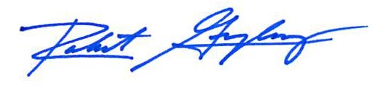

Robert F. Gonzalez, Esq.

Fla. Bar No. 68865

[Pleadings@flinslaw.com](mailto:Pleadings@flinslaw.com)